Alert Watch and Response Engine (AWARE)

CPRS Integration Specification



May 2014

Prepared by Harris Corporation

CLIN 0002AC

Revision History

| **Creation Date** | **Version No.** | **Description/Comments** | **Author(s)** | **Reviewer(s)** | **Review Type** | **Issue Date** |
| --- | --- | --- | --- | --- | --- | --- |
| 10/14/2013 | 0.01 | Initial | I. Valdes |  |  | 11/14/2013 |
| 04/28/2014 | 0.02 | Replaced Figure 1, 3, 5 and 6; Updated Table 1 to reflect Figure 1; Modified ID number in Table 2 to reflect Figure 1; Replaced Table 10 screenshot with Table format; Updated verbiage - 1.1, 1.2, 4.2.1, 4.2.2, 4.2.3.4, 4.2.4.2, 4.2.4.21, 4.2.6.1; 4.2.4.1 - Updated Table 5, created Table 7 | B. Tjahjo | M. Becker S. Greenacre S. Wang G. Welch  I. Valdes | Peer | 05/28/2014 |
|  |  |  |  |  |  |  |
|  |  |  |  |  |  |  |
|  |  |  |  |  |  |  |
|  |  |  |  |  |  |  |
|  |  |  |  |  |  |  |
|  |  |  |  |  |  |  |
|  |  |  |  |  |  |  |
|  |  |  |  |  |  |  |
|  |  |  |  |  |  |  |
|  |  |  |  |  |  |  |
|  |  |  |  |  |  |  |
|  |  |  |  |  |  |  |
|  |  |  |  |  |  |  |
|  |  |  |  |  |  |  |
|  |  |  |  |  |  |  |

Table of Contents

1 Introduction 1

1.1 Purpose 1

1.2 Scope 1

2 Background 2

2.1 Overview of the System 2

2.2 Assumptions and Constraints 2

2.2.1 Integration Assumptions 2

2.2.2 Integration Constraints 2

3 Conceptual Application Integration 3

4 Detailed Design 6

4.1 Hardware Design 6

4.2 Software Design 7

4.2.1 CPRS (1) and AWARE DLL (1a) Modules 7

4.2.2 Processing 9

4.2.3 AWARE /CPRS Integration 12

4.2.4 Design Elements 17

4.2.5 Human Machine Interface 30

4.2.6 Navigation Hierarchy 32

4.2.7 Packaging and Installation 36

5 Attachment A – Approval Signatures 37

List of Tables

Table 1 - AWARE Business Processes Description Table 4

Table 2 - CPRS Objects in Process Design 10

Table 3 - AWARE DLL Objects in Process Design 12

Table 4 - VEFAALRE 17

Table 5 - VEFAALR1 18

Table 6 - VEFAALR2 20

Table 7 - VEFAALR3 21

Table 8 - Data Entries Affected by the Design 22

Table 9 - Options 23

Table 10 - Types Defined Interface 25

Table 11 - Graphical User Interface for AWARE DLL 26

Table 12 - List of Delphi files for Graphical User Interface customized in CPRS 26

Table 13 - New GUI Classes in AWARE DLL 27

Table 14 - Components on Form 28

Table 15 - Events 28

Table 16 - Methods 28

Table 17 - Help Frames 29

List of Figures

Figure 1 - CPRS Integration Application Context Diagram 3

Figure 2 - Patient Closeout 6

Figure 3 - AWARE System Components Diagram 7

Figure 4 - CPRS/AWARE DLL Process Flow Diagram 8

Figure 5 - CPRS Process Design 9

Figure 6 - AWARE DLL Process Design 11

Figure 7 - “Prompt Screen” User Interface 13

Figure 8 - Reminder Dialog 14

Figure 9 - User Setup 15

Figure 10 - User Setup Continued (above) 15

Figure 11 - Prompting Screen 28

Figure 12 - Help Frame 29

Figure 13 - CPRS Prompting Screen 30

Figure 14 - CPRS Patient Selection Screen 31

Figure 15 - Select New Patient 32

Figure 16 - Patient Selection 33

Figure 17 - FAT Prompt 33

Figure 18 - Clinic Selection (above) 34

Figure 19 - Clinic Selection (continued) 35

Figure 20 - Progress Note Title Selection 35

Figure 21 - Reminder Dialog Present 36

# Introduction

The Computerized Patient Record System (CPRS) View Alerts package delivers notification of non-life threatening critical test results; however, it does not track whether providers take appropriate follow-up actions in response to the alerts. Currently, the only way to track follow-up actions on critical alerts is through a manual review of individual patient records. The innovation Alert, Watch and Response Engine (AWARE) will track and monitor follow-up actions, and will identify certain critical lab and imaging test result alerts that lack timely follow-up.

## Purpose

The purpose of this document is to describe how AWARE will be integrated with the current version of CPRS. CPRS’ integration with AWARE functions as the core part of the AWARE system for specific patient alerts involving patient safety. It is the basis for re-direction prompting of a patient’s provider(s) for processing timely follow-up actions on specific alerts. When these follow-up actions are completed, they help serve Veterans Affairs (VA)-desired goals for providing excellent clinical care and matching patient safety measures for Veterans.

## Scope

The scope of this document is limited to describing the AWARE integration with CPRS. The breadth of the scope is as follows:

Inclusions:

* Dynamic-link library (DLL)’s for normal, abnormal, and incomplete test result critical alert detection
* CPRS Modifications
* VistA server files and data structure
* CPRS v29

Exclusions:

* Non-VistA systems

# Background

## Overview of the System

Currently, there is no effective way to monitor or track abnormal test results in CPRS suspicious for malignancy, which can potentially cause unnecessary delay in, and lack of appropriate follow-up care for patients. In addition, there is no system in place within CPRS that has the capacity to identify, monitor, and track milestones in the diagnostic work-up and treatment of abnormal results. Paired with National clinical reminders and the proposed tracking of abnormal and incomplete test results capability, this functionality will improve detection, diagnosis, treatment, and management of conditions suspicious for malignancy in the Veterans Health Administration (VHA).

## Assumptions and Constraints

This section describes the assumptions and constraints that impact the AWARE design.

### Integration Assumptions

* An entry point can be made to exist within CPRS for on-chart closeout calls to a .dll file.
* Integration will occur with CPRS v29.

### Integration Constraints

* Inherent VistA system limitations.
* The ability to deploy a new version of CPRS and a new .dll.

# Conceptual Application Integration

AWARE consists of a knowledge base alert tracker, which integrates with CPRS in such a manner as to provide a CPRS user (provider) with critical decision support (CDS) information regarding tracked, unacknowledged alerts. The element components of an overall AWARE system are depicted in Figure 1 below as element #1 for CPRS and element #1a for the AWARE alert tracker.

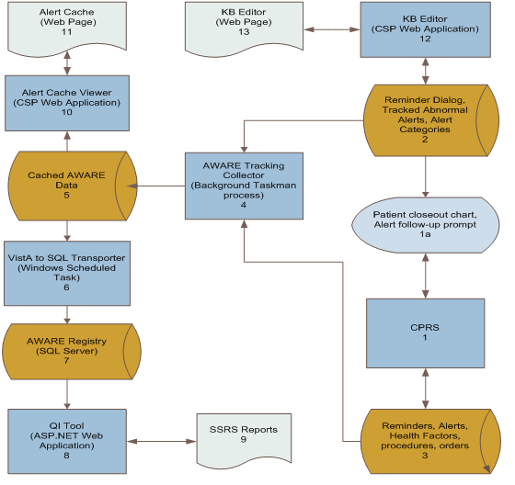

Figure 1 - CPRS Integration Application Context Diagram

Brief descriptions of the other business elements in the overall AWARE system are shown in Table 1, as well as CPRS itself (item 1) and the AWARE Alert Tracker (item 1a) integration shown above in Figure 1.

Table 1 - AWARE Business Processes Description Table

| **Business Process ID** | **Business Process Name** | **Type** | **Owner** | **Description** |
| --- | --- | --- | --- | --- |
| 1 | CPRS | Existing | Clinicians and Quality Management personnel | CPRS is the primary GUI for VistA. Patient closeout chart and the Alert follow-up prompt are called from VistA and displayed in CPRS (as in 1a). |
| 1a | Patient closeout prompt, View notification alert, Reminders | New | CPRS users | Alerts users that results exist for the patient test results and prompts users to take action on completing a follow-up/treatment recommendation.  If the provider takes an action on the abnormal result while working in the chart, this prompt will be suppressed on the chart close out and it will NOT be displayed to the provider. |
| 2 | Reminder Dialog, Data Store, Tracked Abnormal Alert type and Alert Categories | New | CPRS users and Quality Management personnel | The data store contains tracked normal, abnormal, and incomplete alert types and alert categories, as well as, corresponding reminder dialogs and associated data to be used for AWARE. |
| 3 | Reminders and associated information Data Store | Enhanced | CPRS users, Quality Management personnel and population demographers | Reminders, Alerts, Health Factors, procedures, orders |
| 4 | Aware Tracking Collector | New | CPRS users, Quality Management personnel and population demographers | This Taskman Tracking Collector will query alert follow-up information tracked from business process 1a (Patient closeout chart, Alert follow-up prompt) in addition to generalizing to other conditions such as occult blood, normal, abnormal and incomplete PSA and other alert types. |
| 5 | Cached AWARE data | New | CPRS users and Quality Management personnel | The collector stores AWARE alerts in this VistA file. Any alerts beyond 2 weeks old will be truncated. |
| 6 | VistA to SQL Transporter | New | CPRS users, Quality Management personnel and population demographers | This C# application connects to VistA to retrieve cached AWARE data and transports to the SQL Server. |
| 7 | AWARE Registry (SQL Server) | New | CPRS users, Quality Management personnel and population demographers | Alert Cache data is stored in the SQL AWARE Registry for historical and statistical purposes. Other QI Tool related tables are also stored in the SQL Server. |
| 8 | QI Tool | New | CPRS users, Quality Management personnel and population demographers | This ASP.NET application is using SSRS Report Viewer to allow provider and patient safety officer to view AWARE Alerts historical and statistical reports. |
| 9 | SQL Server Reporting Services (SSRS) Reports | Existing/Enhanced | CPRS users, Quality Management personnel and population demographers | Tracked Alert follow-up performance statistics.  Predefined and ad hoc reports will be generated as users request to display information collected and stored in the system. |
| 10 | Alert Cache Viewer (CSP) | New | CPRS users and Quality Management personnel | This CSP application serves browser request to retrieve VistA Alert Cache file and return the contents to the browser. |
| 11 | Alert Cache (Web Page) | New | CPRS users and Quality Management personnel | Providers and patient safety officers use this web interface to view Alert Cache data. |
| 12 | Knowledge Base (KB) Editor (CSP) | New | CAC | This CSP application serves browser request to add, edit, and validate VistA Alert Category and Alert Type files. |
| 13 | KB Editor  (Web Page) | New | CAC | This web interface allows CAC to create and/or edit Alert Categories and Alert Types. |

Upon patient closeout, an AWARE Prompt Display will appear as shown the figure below. This prompt will notify the clinician of an abnormal or incomplete mammogram requiring attention. The clinician has the option to click the ‘Address Now’ button, or click the ‘Close and Address Later’ button and continue back to the Patient Chart.

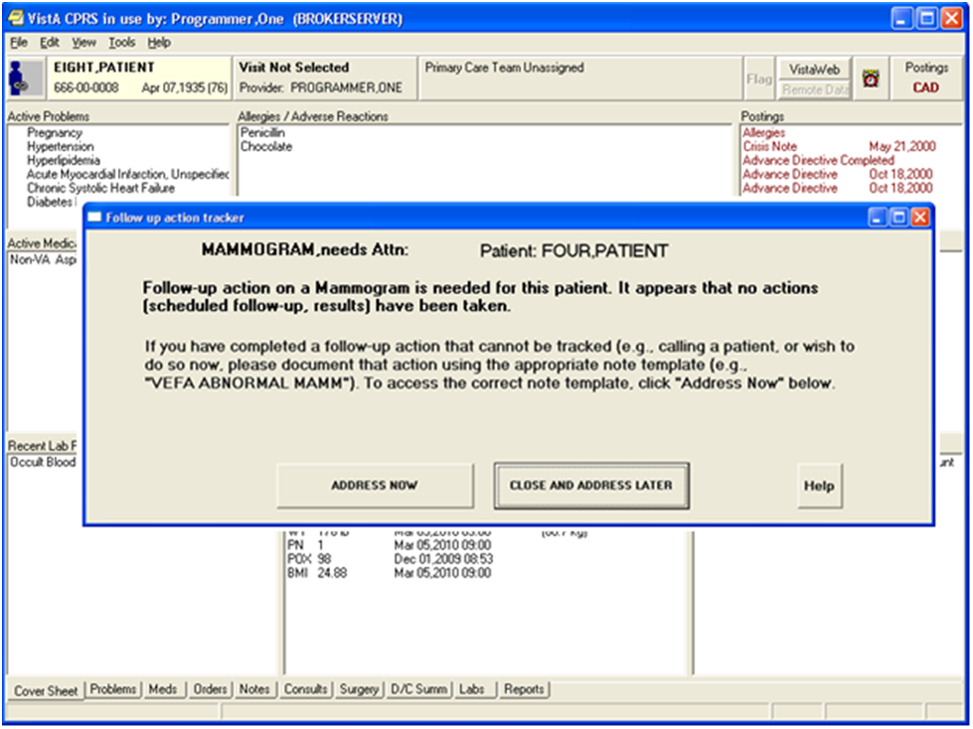

Figure 2 - Patient Closeout

# Detailed Design

The design for the CPRS/AWARE DLL integration is described in detail in this section.

## Hardware Design

Client Workstations running CPRS are connected to VistA servers**.**

## Software Design

### CPRS (1) and AWARE DLL (1a) Modules

The figure below shows an overall process diagram of the AWARE functionality, components and data flow.



Figure 3 - AWARE System Components Diagram

The “Patient closeout chart, Alert follow-up prompt” is from an AWARE Dynamic Link Library (DLL) integrated with CPRS (noted as 1a in the above diagram). The AWARE DLL is a Component Object Model (COM) object called from CPRS at patient closeout during the selection of a different patient. Before this new patient selection is actually allowed, an alert tracker function in the AWARE DLL determines if a follow-up action(s) has been made for any AWARE tracked alert for the prior patient. If none have been made, a prompt screen appears so the user can address this issue. A choice can be made by the provider to do a follow-up action via subsequent re-direction to a specific CPRS reminder dialog. This is Follow-up Action Tracking (FAT).

The CPRS/AWARE DLL Modules Process Flow is shown in Figure 4 below:

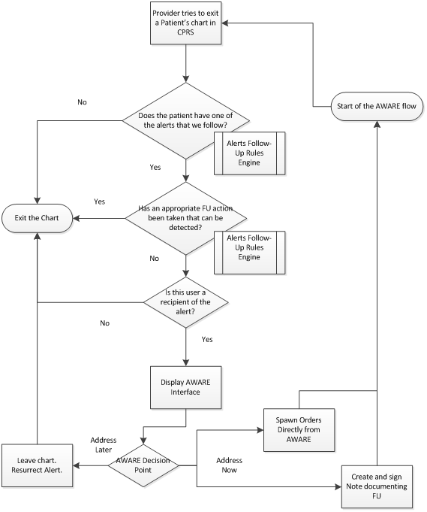

Figure 4 - CPRS/AWARE DLL Process Flow Diagram

### Processing

The CPRS/AWARE DLL module(s) integration is the core processing part of the AWARE system and is related to other modules in the systems. Additional modules are part of the overall AWARE system, but these are beyond the scope of the CPRS Integration Specifications document.

The module connections are described next.



Figure 5 - CPRS Process Design

The following table maps the above figure to its corresponding VistA object.

Table 2 - CPRS Objects in Process Design

|  |  |  |  |  |  |  |  |  |  |  |
| --- | --- | --- | --- | --- | --- | --- | --- | --- | --- | --- |
| **Objects** | | | | | | | | | | |
| **ID** | **Name** | **Description** | | **Service or Legacy Code** | **External Interface Name** | | **External Interface ID** | **Internal Interface Name** | | **RSD** |
| 1 | CPRS | Source for clinician supplied data including reminders (screening, other, etc., procedures, orders, health factors, etc.) | | Alert tracking monitoring including abnormal alert results, reminder dialogs. |  | |  | CPRS with progress notes, reminder dialogs. | | 2.6.3.3,  2.6.3.4 |
| **Internal Data Stores** | | | | | | | | | | |
| **ID** | **Name** | | **Data Stored** | | | **Steward** | | | **Access** | |
| 3 | Data store for merge of real-time data from CPRS. | | Merge of CPRS reminder dialog resulting for screenings, additional monitored real-time data as required during course of alert tracking, procedures, orders, and health factors merged with data retrieved from cached collections. | | | Clinicians/Authorized users for reminder dialogs, procedures, orders directly and data retrieved from cached collections. | | | CRUD (Creation, Retrieval, Updating, and Deletion) operations -Write/Read. | |

The AWARE DLL (module 1a with arrow below) is shown in Figure 6.

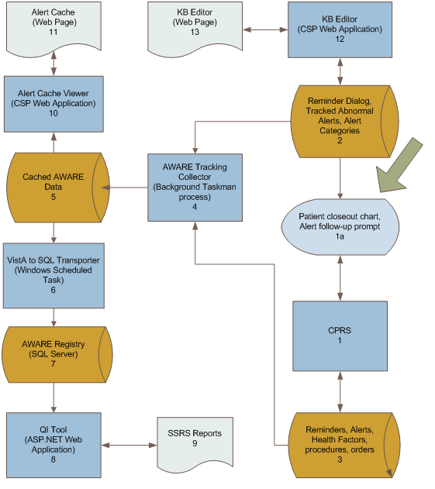

Figure 6 - AWARE DLL Process Design

The following table maps the AWARE dll to its corresponding VistA object(s).

Table 3 - AWARE DLL Objects in Process Design

|  |  |  |  |  |  |  |  |  |  |  |  |
| --- | --- | --- | --- | --- | --- | --- | --- | --- | --- | --- | --- |
| **Objects** | | | | | | | | | | | |
| **ID** | **Name** | **Description** | | **Service or Legacy Code** | **External Interface Name** | | **External ID** | **Internal Interface Name** | | **Internal Interface ID** | **RSD** |
| 1a | Patient Closeout Chart. Alert Follow-up prompt  (AWARE DLL) | Abnormal Test Results Follow-up initiation (prompting)  And redirection for provider Follow-up actions in a Reminder Dialog | | Prompting as Follow-up initiation opportunity | VistA Extraction Input Transmitter into SQL server storage | | 6 | CPRS  Alert Tracking Collector | | 1  3 | 2.6.3.1,  2.6.3.2 |
| **Internal Data Stores** | | | | | | | | | | | |
| **ID** | **Name** | | **Data Stored** | | | **Steward** | | | **Access** | | |
| 2 | Reminder Dialogs, associated tracked abnormal alerts and alert categories | | Reminder Dialogs, associated tracked abnormal alerts and alert categories | | | Providers ( clinicians) and via Web editor by CAC use to edit tracked alert categories and alert types | | | CRUD operations. Read tracked  Read of tracked abnormal resulting alerts, alert categories.  Generate/Display Follow-up Action  Tracking Prompts | | |

### AWARE /CPRS Integration

AWARE as an alert tracker is not a standalone application. It is a “COM” object, which needs CPRS as its calling program to promote its functions with dialogs and pathways, which can be re-directed with recommendations AWARE makes available to CPRS. The recommendations assist the provider (clinician) with performing the appropriate follow-up actions for an unacknowledged abnormal resulting alert. AWARE uses a knowledge base that contains information about alert notification categories and alert types to be tracked.

#### Local Data Structures

Local data structures, which are part of the business knowledge base rules for guiding re-direction opportunities to addressing follow-up actions, include the following for the CPRS/AWARE DLL integration:

* A FileMan file for a various tracked alert categories of eligible alert notifications ( i.e. Abnormal Alert (AA) critical lab alert category)
* A FileMan file of specific tracked alert types ( i.e., critical PSA lab result alert)
* For each specific tracked alert type, a link to an associated Reminder dialog
* For Reminder dialog and associated Text Integration Utilities (TIU) template
* The VA FileMan National Alert and Alert Tracking files

The actual details for connected follow-up actions via the associated Reminder dialog/TIU template are defined by Clinical Application Coordinators (CACs) who are responsible for their proper design using a VA CPRS reminder dialog builder. These reminder dialogs have many sub-components, such as use of various VA FileMan files including those for orderable items (pharmacy orderable items, facility lab test names), consults, text comments, health factors, procedures, orders, and other available data structure elements that are naturally used by CACs in the design of Reminder dialogs as composite Reminder dialog elements. Guidance will be provided as part of AWARE project for specific features needed in the design of these Reminder Dialog designs for proper FAT workings.

In addition, as an auxiliary function (but outside this CPRS/AWARE DLL integration), a new file for Tracked Alert auditing/logging will be designed as a sort of cache for local facility access by authorized users, and as a source for aggregating daily alert tracking information for eventual transfer and storage into SQL Server database tables as historical data for reporting purposes.

#### User Interfaces

The AWARE DLL Follow-up Action tracking module provides a redirected prompt screen for a provider to consider follow-up action for their patient upon the occurrence of a tracked alert while the patient is being seen in CPRS. An example of this user interface is shown as below in Figure 7.

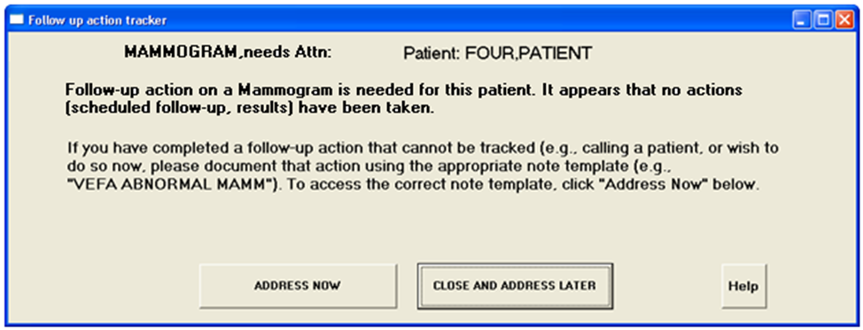

Figure 7 - “Prompt Screen” User Interface

Upon clicking the “ADDRESS NOW” button, the user will be re-redirected automatically to a specific Reminder dialog associated with that type of tracked alert. An example of this is shown in Figure 8 below.

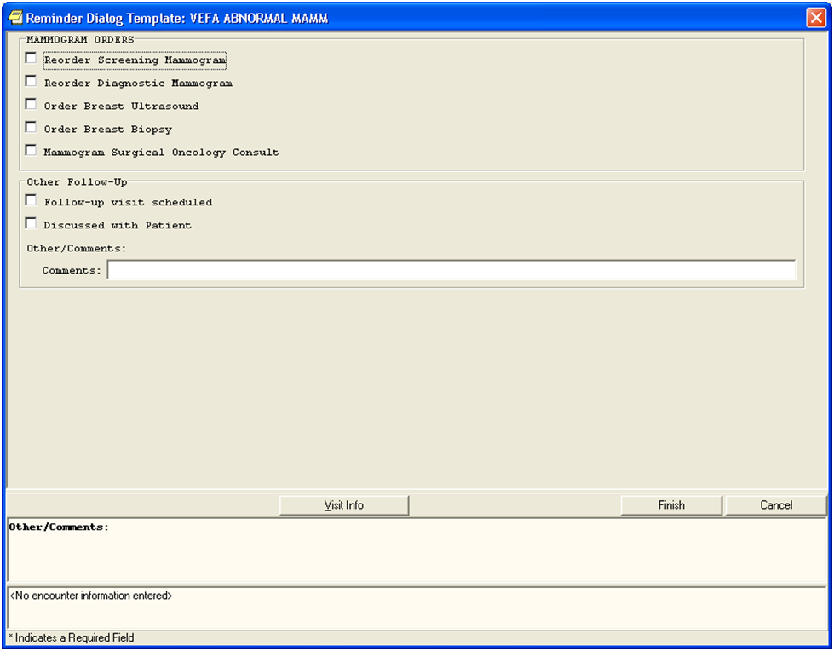

Figure 8 - Reminder Dialog

The logical configuration necessary per user to allow for this screen prompting and choice for follow-up actions depends on the following:

* Each user of the AWARE system must have the AWARE DLL registered on their desktop.
* Setup of alert notification types to be monitored per user should include those alert types the AWARE system is monitoring. Usually these are set up as default for all users, but they can be customized for each user so they can be aware and see these actual tracked alert notifications. These notifications are configurable within CPRS per user as shown below in Figure 9 and Figure 10. They are also configurable on system-wide or default basis through the CPRS options that are available to CACs.

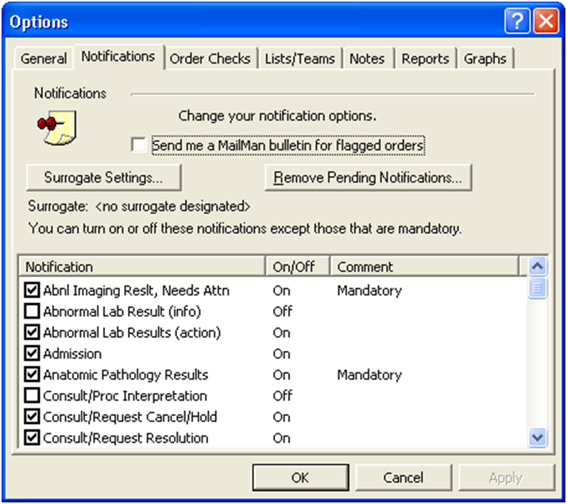

Figure 9 - User Setup

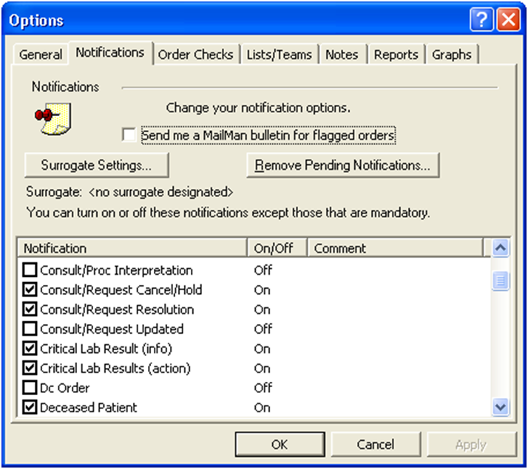

Figure 10 - User Setup Continued (above)

* Allowing specific Reminder Dialogs to be user-connected with a defined TIU Template for an associated tracked alert type. This connection can be based on a specific user, or by service, division, or system level. The user configuration is done by CACs as part of their normal duties for use of Reminder Dialogs. The TIU template should also be a Shared TIU template available to all or certain groups of users.

#### Hardware Interfaces

1. *Desktop PCs for running CPRS/AWARE DLL with an AWARE DLL interface with VistA server machine(s).
2. *MUMPS VistA server machine(s) with underlying Linux,VMS, or MS Windows operating systems for communications between CPRS/AWARE DLL and VISTA server data.
3. Windows Server machine per facility with configured SQL Server and IIS Internet Information System for storage of data received from a VistA server, and for authorized user viewing, long term historical reporting, and other configuration purposes.

Asterisk (*) indicates the only hardware interfaces for the basic CPRS/AWARE integration specifications for this document.

The other additional aforementioned interfaces mentioned here are part of the overall AWARE system specification.

#### Software Interfaces

1. **Client interface using CPRS/AWARE DLL with AWARE DLL software interfaces with VistA data using Remote Procedure Calls (RPCs).
2. **VistA data retrieved and written from an AWARE DLL using VA Remote Procedure Calls (RPCs).
3. SQL Server data storage of received VistA data, and web display for authorized user viewing, long term historical reporting, and other configuration purposes.
   1. The long-term storage retrieval will be by RPC and transfers from a scheduled Windows Scheduled task.
   2. Reporting functions through web server includes those for historical reporting such as those employed with MS SQL Server Reporting Services (web dashboards). It also includes authorized user viewing of current or recent tracked alert activity from a facility such as via web displays with access to VistA data via Cache Server Page (CSP).
   3. A Web Graphical User Interface (GUI) alert tracking knowledge base editor for creation/editing of AWARE knowledge base rules for each facility using VistA data that will be retrieved via CSP.

Double asterisk (**) indicates the only software interfaces for the basic CPRS Integration Specifications for this document.

The other additional aforementioned interfaces are part of an overall AWARE System Specifications including planned enhancements.

#### User Characteristics

Users of the CPRS/AWARE DLL include clinician staff and end users are the ones who perform alert follow-up actions to be tracked. Refer to the AWARE RSD Section 2.6, Functional Specification sections 2.6.3.1 and 2.6.3.2.

As related but separate from user clinicians with the CPRS/AWARE DLL Integration, are clinicians, authorized users, administrative and executive level staff, including patient safety officers, as users who do additional viewing and reporting of this data.

#### Dependencies and Constraints

Section 508 compliance is required for CPRS usage in CPRS/AWARE DLL integration. CPRS is a VA Class 1 product.

### Design Elements

#### Design Element Tables (Routines)

Table 4 - VEFAALRE

| Routine Name | VEFAALRE | | | | | | |
| --- | --- | --- | --- | --- | --- | --- | --- |
| Enhancement Category | New | Modify | Delete | | | No Change | |
| RTM(RSD) | RSD 2.6.3 AWARE/CPRS INTEGRATION  Alert tracker(2.6.3.1,2.6.3,2), FAT Prompt in CPRS from AWARE DLL (2.6.3.3.1) | | | | | | |
| Related Options |  | | | | | | |
| **Related Routines** | **Routines “Called By”** | | | | **Routines “Called”** | | |
|  | VEFAALR1 | | | | **Label Reference**  **LKPORD** | | |
| Data Dictionary & Global References | ^AUPNVHF(  ^AUPNVHF("C"  ^AUPNVSIT(  ^AUTTHF(  ^DIZ(19007  ^OR(100  ^ORD(101.43  ^PXRMD(801.41  ^TMP($J | | | | | | |
| Data Passing Details | Remote Procedure Calls (RPCs)  NAME: VEFALKPORD TAG: LKPORD  ROUTINE: VEFAALRE RETURN VALUE TYPE: SINGLE VALUE  AVAILABILITY: PUBLIC VERSION: 1  DESCRIPTION:  Do a lookup for specific critical alert TYPE, and associated date/time of  l unacknowledged alert, and check whether  ;any ORDERS by user (DUZ)have been made from list of orders in a possible  e defined VEFA ALERT TRACKING entry's Reminder Dialog  ;(field), the dialog elements thereof containing the ORDER types (orderable  items) for such list to be compared with any actual orders,  ; by this user (DUZ) made after the date/time of the actual critical alert.  ;First Verify also that type of alert passed is in VEFA ALERT TRACKING file  for "follow-up" purposes, and has defined REMINDER DIALOG.  INPUT PARAMETER: INPUT VALUE PARAMETER TYPE: LITERAL  MAXIMUM DATA LENGTH: 120 REQUIRED: YES | | | | | | |
| Related Integration Agreements |  | | | | | | |
| Data Passing | Input | Output Reference | | Both | | Global Reference | Local |
| Input Attribute Name and Definition | Name: ;  Verify alert is tracked alert type, | | | | | | |
| Output Attribute Name and Definition | ; Output : None | | | | | | |

Table 5 - VEFAALR1

| Routine Name | VEFAALR1 | | | | | | |
| --- | --- | --- | --- | --- | --- | --- | --- |
| Enhancement Category | New | Modify | Delete | | | No Change | |
| RTM(RSD) | RSD 2.6.3, AWARE/CPRS INTEGRATION 2.6.3.1,2.6.3.2 and 2.6.3.3.2 and 2.6.3.3.3 (renew alert)  Alert tracker, Re-new deleted alert in AWARE DLL via RPC routine  Assist with collection of data for viewing/subsequent reporting purposes | | | | | | |
| Related Options |  | | | | | | |
| **Related Routines** | **Routines “Called By”** | | | | **Routines “Called”** | | |
| VEFAALR9  VEFAALR6 | | | | External References  C^%DTC  NOW^%DTC  ^DIC  YN^DICN  $$CAT^VEFAALR1  $$SERVICE^VEFAALR1  $$STATUS^VEFAALR1  LKPORD^VEFAALR2  LKPORDCK^VEFAALRE  UPDATE^DIE | | |
| Data Dictionary & Global References | ^DD("DD"  ^DIC(4  ^DIC(49  ^DIZ(19007  ^DIZ(19008  ^DPT(  ^VA(200  ^XTV(8989.3  ^XTV(8992  ^XTV(8992.1 | | | | | | |
| Data Passing Details | Remote Procedure Calls (RPCs)  NAME: VEFA CRIT ALERT TRACKED TAG: LOOKUP  ROUTINE: VEFAALR1 RETURN VALUE TYPE: SINGLE VALUE  AVAILABILITY: PUBLIC VERSION: 1  INPUT PARAMETER: INPUT VALUE PARAMETER TYPE: LITERAL  MAXIMUM DATA LENGTH: 120 REQUIRED: YES  DESCRIPTION: LIST OF TRACKED ALERTS  Collection/assembly of Alert tracking Data for viewing/subsequent viewing/reporting  CODE:  MUMPS CODE: S X=$$CAT^VEFAALR1(X)  EXPLANATION: IS ALERT TYPE IN VEFA ALERT TRACKING CATEGORY/NOTIFICATION TYPE  MUMPS CODE: S X=$$DATEFMT^VEFAALR1(X)  EXPLANATION: RETURN DATE FORMATTED  MUMPS CODE: S X=$$FOLLOWU1^VEFAALR1(X)  EXPLANATION: FOLLOWUP ACTION (S) COMPLETED FOR SPECIFIC PASSED FAT ALERT (AS X)  MUMPS CODE: S X=$$ORDERCK1^VEFAALR1(X)  EXPLANATION: RETURN A CONCATENATED LIST (";") DELIMITED OF FAT ORDER/FOLLOW-UPS MADE FOR AN ALERT  MUMPS CODE: S X=$$STATUS^VEFAALR1(X)  EXPLANATION: RETURN UNACKNOWLEDGED STATUS^RENEW(PROCESSED) DATE^ACKNOWLEDGED OR DELETED DATE  MUMPS CODE: S X=$$SERVICE^VEFAALR1(X)  EXPLANATION: RETURN SYSTEM/CLINIC (SERVICE/SECTION FILE ENTRY) OF PASSED ALERT TRACKING ENTRY | | | | | | |
| Related Integration Agreements |  | | | | | | |
| Data Passing | Input | Output Reference | | Both | | Global Reference | Local |
| Input Attribute Name and Definition | Name: Sorting/print arrays for collection/assembly of follow-up actions | | | | | | |
| Output Attribute Name and Definition | ; Output Renew Alert in Alert Tracking file | | | | | | |

Table 6 - VEFAALR2

| Routine Name | VEFAALR2 | | | | | | |
| --- | --- | --- | --- | --- | --- | --- | --- |
| Enhancement Category | New | Modify | Delete | | | No Change | |
| RTM(RSD) | RSD 2.6.3 AWARE/CPRS INTEGRATION 2.6.3.1 and 2.6.3.2,  And 2.6.3.3.1  Alert tracker, FAT Prompt in AWARE DLL RPC routine | | | | | | |
| Related Options |  | | | | | | |
| **Related Routines** | **Routines “Called By”** | | | | **Routines “Called”** | | |
|  | VEFAALR1 | | | | External References | | |
| Data Dictionary & Global References | ^AUPNVHF(  ^AUPNVHF("C"  ^AUPNVSIT(  ^DIZ(19007  ^DIZ(19008  ^OR(100  ^PXRMD(801.41  ^TIU(8927  ^TMP("ORVEFACAT"  ^TMP("ORVEFAFOL"  ^TMP("ORVEFAORD"  ^TMP($J | | | | | | |
| Data Passing Details | Remote Procedure Calls (RPCs)  NAME: VEFA CRIT ALERT VALUES TAG: SPECALRT  ROUTINE: VEFAALR2 RETURN VALUE TYPE: SINGLE VALUE  AVAILABILITY: RESTRICTED INACTIVE: ACTIVE  WORD WRAP ON: TRUE VERSION: 1  DESCRIPTION:  RETURN REMINDER DIALOG AND TIU TEMPLATE FROM PASSED CRIT ALERT IN FILE 19007  INPUT PARAMETER: INPUT VALUE PARAMETER TYPE: LITERAL  MAXIMUM DATA LENGTH: 120 REQUIRED: YES  NAME: VEFA ALERT DOC FOLLOWUPS TAG: ALERTFOL  ROUTINE: VEFAALR2 RETURN VALUE TYPE: GLOBAL ARRAY  AVAILABILITY: RESTRICTED INACTIVE: ACTIVE  WORD WRAP ON: TRUE  DESCRIPTION:  RETURN LIST OF FOLLOWUPS AS DOCS OF FOLLOWUPS IN REMINDER DIALOG  INPUT PARAMETER: INPUT VALUE PARAMETER TYPE: LITERAL  MAXIMUM DATA LENGTH: 120 REQUIRED: YES  NAME: VEFA ALERT DOC ORDERS TAG: ALERTORD  ROUTINE: VEFAALR2 RETURN VALUE TYPE: GLOBAL ARRAY  AVAILABILITY: RESTRICTED INACTIVE: ACTIVE  WORD WRAP ON: TRUE  DESCRIPTION:  RETURN ORDERS IN ORDERS GROUP DIALOG AS DOCS OF REMINDER DIALOG  INPUT PARAMETER: INPUT VALUE PARAMETER TYPE: LITERAL  MAXIMUM DATA LENGTH: 120 REQUIRED: YES  DESCRIPTION:  NAME: VEFAALERTCAT TAG: ALERTCAT  ROUTINE: VEFAALR2 RETURN VALUE TYPE: GLOBAL ARRAY  AVAILABILITY: RESTRICTED INACTIVE: ACTIVE  WORD WRAP ON: TRUE  DESCRIPTION:  RETURN ARRAY OF CRITICAL ALERT CATEGORIES AND THEIT NOTIFICATION TYPES | | | | | | |
| Related Integration Agreements |  | | | | | | |
| Data Passing | Input | Output Reference | | Both | | Global Reference | Local |
| Input Attribute Name and Definition | Name:   Pass Critical Alert to receive reminder dialog, TIU template, order and follow-ups, Date ranges for collection/assembly of follow-up action, | | | | | | |
| Output Attribute Name and Definition | ; Output : None | | | | | | |

Table - VEFAALR3

| Routine Name | VEFAALR3 | | | | | | |
| --- | --- | --- | --- | --- | --- | --- | --- |
| Enhancement Category | New | Modify | Delete | | | No Change | |
| RTM(RSD) | RSD 2.6.3 AWARE/CPRS INTEGRATION 2.6.3.1 and 2.6.3.2,  And 2.6.3.3.1  Alert tracker, Test Imaging alert types | | | | | | |
| Related Options |  | | | | | | |
| **Related Routines** | **Routines “Called By”** | | | | **Routines “Called”** | | |
| VEFAALR1 | | | | External References  C^%DTC  NOW^%DTC  ^DIC  YN^DICN  UPDATE^DIE  $$CAT^VEFAALR1  $$SERVICE^VEFAALR1  $$STATUS^VEFAALR1 | | |
| Data Dictionary & Global References | ^DD("DD"  ^DPT(  ^XTV(8992.1 | | | | | | |
| Data Passing Details |  | | | | | | |
|  |  | | | | | | |
| Related Integration Agreements |  | | | | | | |
| Data Passing | Input | Output Reference | | Both | | Global Reference | Local |
| Input Attribute Name and Definition | Name:   Pass Critical Alert to receive reminder dialog, TIU template, order and follow-ups, Date ranges for collection/assembly of follow-up action, | | | | | | |
| Output Attribute Name and Definition | ; Output : None | | | | | | |

#### Templates

Not applicable.

#### Bulletins

Not applicable.

#### Unique Record(s)

Table - Data Entries Affected by the Design

| **Field Name(s)** | **Current Value** | **New Value** |
| --- | --- | --- |
| ORWCOM VEFA PAT CHART CLOSEOUT parameter value as defined in the PARAMETER DEFINITION file. Add new record | None | TRUE |

#### Mail Groups

Not applicable.

#### Security Keys

Not applicable.

#### Options

Table - Options

| **Options** | **Activities** | | | | | | | | | | |
| --- | --- | --- | --- | --- | --- | --- | --- | --- | --- | --- | --- |
| **Option Name** | Select OPTION NAME: VEFAALRE VEFA ALRE CONTEXT  ANOTHER ONE:  STANDARD CAPTIONED OUTPUT? Yes// (Yes)  Include COMPUTED fields: (N/Y/R/B): NO// - No record number (IEN), no Computed  Fields  NAME: VEFAALRE MENU TEXT: VEFA ALRE CONTEXT  TYPE: Broker (Client/Server) CREATOR: PROGRAMMER,ONE  TIMESTAMP OF PRIMARY MENU: 62583,83322  RPC: ORWORB FASTUSER  RPC: VEFALKPORD  RPC: VEFA CRIT ALERT TRACKED  RPC: VEFAALERTCAT  RPC: VEFA CRIT ALERT VALUES  RPC: VEFA ALERT DOC ORDERS  RPC: VEFA ALERT DOC FOLLOWUPS  UPPERCASE MENU TEXT: VEFA ALRE CONTEXT | | | | | | | | | | |
| **Enhancement Category** | New | Modify | | | | Delete | | | No Change | | |
| **Associated Menu Options that will invoke this reference** | Added to CPRS context option OR CPRS GUI CHART | | | | | | | | | | |
| **Data Passing** | Input | | Output | | Both | | | Global Reference | | | Local Reference |
| **Menu Text Description** |  | | | | | | | | | | |
| **Option Type** | Edit | | | Print | | | Menu | | | Inquire | |
|  | Action | | | Run Routine | | | Other | | | Broker (Client/Server) type for Context for DLL usage | |
| **Associated Routine** |  | | | | | | | | | | |
| **Option Definition** | Context for GUI usage of AWARE DLL | | | | | | | | | | |

| **Current Entry Action Logic** |
| --- |
|  |

| **Modified Entry Action Logic (Changes are in bold)** |
| --- |
|  |

| **Current Exit Action Logic** |
| --- |
|  |

| **Modified Exit Action Logic (Changes are in bold)** |
| --- |
|  |

#### Protocols

Not applicable.

#### Remote Procedure Calls (RPCs)

OUTPUT FROM WHAT FILE: OPTION// REMOTE PROCEDURE (3025 entries)

Select REMOTE PROCEDURE NAME: ORWCOM VEFA PT CLSCHART

ANOTHER ONE:

STANDARD CAPTIONED OUTPUT? Yes// (Yes)

Include COMPUTED fields: (N/Y/R/B): NO// - No record number (IEN), no Computed

Fields

NAME: ORWCOM VEFA PT CLSCHART TAG: PTCLS

ROUTINE: ORWCOM RETURN VALUE TYPE: SINGLE VALUE

AVAILABILITY: RESTRICTED WORD WRAP ON: TRUE

DESCRIPTION:

Returns COM Object entries from different parameters.

RETURN PARAMETER DESCRIPTION:

Zero Node from File 101.15

Note **ORWCOM VEFA PT CLSCHART RPC is added to CPRS context option ORWCOM VEFA PT CLSCHART

REMOTE PROCEDURE LIST NOV 3,2013 19:18 PAGE 1

--------------------------------------------------------------------------------

NAME: VEFA ALERT DOC FOLLOWUPS TAG: ALERTFOL

ROUTINE: VEFAALR2 RETURN VALUE TYPE: GLOBAL ARRAY

AVAILABILITY: RESTRICTED INACTIVE: ACTIVE

WORD WRAP ON: TRUE

DESCRIPTION:

RETURN LIST OF FOLLOWUPS AS DOCS OF FOLLOWUPS IN REMINDER DIALOG

INPUT PARAMETER: INPUT VALUE PARAMETER TYPE: LITERAL

MAXIMUM DATA LENGTH: 120 REQUIRED: YES

NAME: VEFA ALERT DOC ORDERS TAG: ALERTORD

ROUTINE: VEFAALR2 RETURN VALUE TYPE: GLOBAL ARRAY

AVAILABILITY: RESTRICTED INACTIVE: ACTIVE

WORD WRAP ON: TRUE

DESCRIPTION:

RETURN ORDERS IN ORDERS GROUP DIALOG AS DOCS OF REMINDER DIALOG

INPUT PARAMETER: INPUT VALUE PARAMETER TYPE: LITERAL

MAXIMUM DATA LENGTH: 120 REQUIRED: YES

DESCRIPTION:

REMOTE PROCEDURE LIST NOV 3,2013 19:18 PAGE 2

--------------------------------------------------------------------------------

RECORD NUMBER OF VEFA CRIT ALERT TRACKING FILE "ALERT TYPE"

NAME: VEFA CRIT ALERT TRACKED TAG: LOOKUP

ROUTINE: VEFAALR1 RETURN VALUE TYPE: SINGLE VALUE

AVAILABILITY: PUBLIC VERSION: 1

INPUT PARAMETER: INPUT VALUE PARAMETER TYPE: LITERAL

MAXIMUM DATA LENGTH: 120 REQUIRED: YES

NAME: VEFA CRIT ALERT VALUES TAG: SPECALRT

ROUTINE: VEFAALR2 RETURN VALUE TYPE: SINGLE VALUE

AVAILABILITY: RESTRICTED INACTIVE: ACTIVE

WORD WRAP ON: TRUE VERSION: 1

DESCRIPTION:

RETURN REMINDER DIALOG AND TIU TEMPLATE FROM PASSED CRIT ALERT IN FILE 19007

INPUT PARAMETER: INPUT VALUE PARAMETER TYPE: LITERAL

MAXIMUM DATA LENGTH: 120 REQUIRED: YES

NAME: VEFAALERTCAT TAG: ALERTCAT

ROUTINE: VEFAALR2 RETURN VALUE TYPE: GLOBAL ARRAY

AVAILABILITY: RESTRICTED INACTIVE: ACTIVE

REMOTE PROCEDURE LIST NOV 03, 2013@19:18 PAGE 3

--------------------------------------------------------------------------------

WORD WRAP ON: TRUE

DESCRIPTION:

RETURN ARRAY OF CRITICAL ALERT CATEGORIES AND THEIT NOTIFICATION TYPES

NAME: VEFALKPORD TAG: LKPORD

ROUTINE: VEFAALRE RETURN VALUE TYPE: SINGLE VALUE

AVAILABILITY: PUBLIC VERSION: 1

DESCRIPTION:

Do a lookup for specific critical alert TYPE, and associated date/time of a rea

l unacknowledged alert, and check whether

;any ORDERS by user (DUZ)have been made from list of orders in a possible

e defined VEFA ALERT TRACKING entry's Reminder Dialog

;(field), the dialog elements thereof containing the ORDER types (orderable

iems) for such list to be compared with any actual orders

;by this user (DUZ) made after the date/time of the actual critical alert.

;First Verify also that type of alert passed is in VEFA ALERT TRACKING file

for "followup" purposes, and has defined REMINDER DIALOG.

INPUT PARAMETER: INPUT VALUE PARAMETER TYPE: LITERAL

MAXIMUM DATA LENGTH: 120 REQUIRED: YES

Press RETURN to continue...

#### Constants Defined Interface

Not applicable.

#### Variables Defined Interface

Not applicable.

#### Types Defined Interface

Table - Types Defined Interface

| *Name* | *Description* |
| --- | --- |
| ORWCOM VEFA PAT CHART CLOSEOUT | Parameter Definition type for allowing parameterization per user, service, system to allow new Patient Closeout Com object entry point in CPRS |

#### Graphical User Interface (GUI)

The AWARE DLL is written in Delphi. See GUI for AWARE DLL

Table - Graphical User Interface for AWARE DLL

| Unit Name | Description |
| --- | --- |
| write4cprsext_TLB.pas | COM object interface library |
| CPRSChart_TLB.pas | COM object CPRS interface |
| writecomobject.pas | Main DLL Alert Tracker module |
| FAT4_textok.dfm | FAT prompt data form |
| FAT4_textok.pas | FAT prompt module |
| AlertIntercept1.pas | Intercept tracked alert module |
| FATHelpScreen.dfm | FAT help screen form |
| FATHelpScreen.pas | FAT help screen module |
| FAT3_textok.dfm | FAT prompt data form |
| FAT3_textok.dfm | FAT prompt module |
| AlertIntercept.pas | Intercept tracked alert module |
| fReminderDialog.dfn | Associated text equivalent reminder dialog form |
| fReminderDialog.pas | Associated text equivalent reminder dialog module |

CPRS is written in Delphi (Delphi code). Customization required for CPRS/AWARE integration.

Table - List of Delphi files for Graphical User Interface customized in CPRS

|  |  |
| --- | --- |
| **Unit Name** | **Description** |
| fEncnt.pas | Provider & Location for Current Activities |
| fNotes.pas | Progress Note Page |
| fptSel.pas | Patient Selection |
| fptSelDemog.pas | Patient Demographics |
| rCore.pas | Collection of Core RPC record types and common RPC related APIs. |
| rEventHooks.pas | Collection of COM related APIs. |
| uCore.pas | Collection of common core classes and Notification APIs |
| uEventHooks.pas | Collection of COM related classes and APIs. |

#### GUI Classes

Table - New GUI Classes in AWARE DLL

| **GUI Classes** | **Instructions** |
| --- | --- |
| Twrite4comobject | Twrite4comobject = class(TAutoObject, Iwrite4comobject, ICPRSExtension)  protected  function Execute(const CPRSBroker: ICPRSBroker;  const CPRSState: ICPRSState; const Param1, Param2,  Param3: WideString; var Data1, Data2: WideString): WordBool;  safecall;  procedure Free ();  procedure AppMessage(var Msg: tagMSG; var Handled: Boolean);  { Protected declarations }  end; |
| **Derived From Class** |  |
| **Purpose** |  |

| **GUI Classes** | **Instructions** |
| --- | --- |
| TFATFormS | TFATFormS = class(TForm) AlertLabel: TLabel;  ButtonLeave: TButton; Label2: TLabel;  Label3: TLabel; PatientName: TLabel;  Label4: TLabel; ReminderInstructions: TLabel;  Button1: TButton; Label9: TLabel;  Button2: TButton; NoteTitle: TLabel;  Button3: TButton;  procedure OnShow(Sender: TObject);  procedure ButtonLeaveClick(Sender: TObject);  procedure Button1Click(Sender: TObject);  procedure Button2Click(Sender: TObject);  procedure Button3Click(Sender: TObject); |
| **Derived From Class** |  |
| **Purpose** |  |

#### Current Form



Figure 11 - Prompting Screen

#### Modified Form

No Change.

#### Components on Form

Name of Form (screen) above in Figure 11 is FAT Prompt screen at time of a Patient closeout (when a new patient selection is made).

Table - Components on Form

| **Name** | **Type** | **Description** |
| --- | --- | --- |
| Type of Alert | Field | Type of tracked alert |
| Patient | Text box | Patient name |
| Prompt and prompt Note template | Dynamic Text box | Description of opportunity to do a follow-up action |
| Address Now | Button | Re-direct CRPS flow into tracked alert associated Reminder Dialog |
| Close and Address Later | Button | **Continue with CPRS normal patient selection** |
| Help | Screen (Form) | Help instructions |

#### Events

Table - Events

| **Name** | **Type** | **Description** |
| --- | --- | --- |
| AWARE DLL call | COM interface (return parameter) | Return dynamic dialog to CPRS |

#### Methods

Table - Methods

| **Name** | **Type** | **Description** |
| --- | --- | --- |
| ICPRSBROKER.Execute | AWARE DLL COM object interface call | **CPRS/AWARE DLL communication interface at time of patient closeout** |

#### CPRS Forms

No existing CPRS forms need to be modified**.**

#### Functions

Not applicable.

#### Dialog

Not applicable.

#### Help Frame

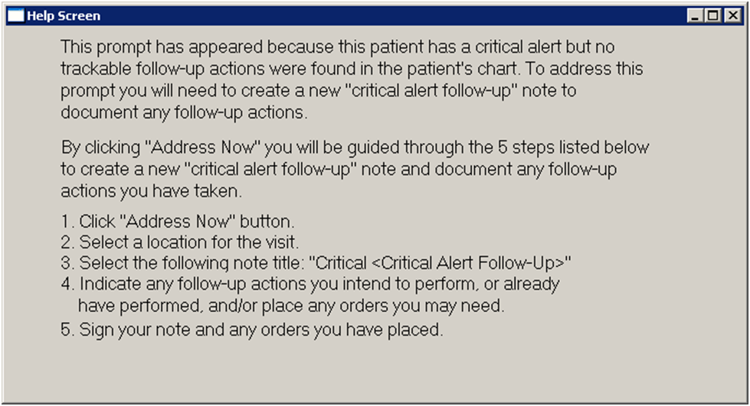

Figure 12 - Help Frame

Table - Help Frames

| *AWARE DLL FAT GUI Help Frame* | *Help for Answering FAT Prompt Form* | | | |
| --- | --- | --- | --- | --- |
| *Help Frame Text* | ***Help Frames*** | | | |
| *Enhancement Category* | *New* | *Modify* | *Delete* | *No Change* |
| *Help Frame Text Calling Mechanism* | *Help Button click* | | | |

| *Current Help Frame Text* |
| --- |
| *As described above* |

| *Modified Help Frame Text (Changes are in bold)* |
| --- |
| *None* |

### Human Machine Interface

Input via CPRS (keyboard and mouse) with normal CPRS access is required, as well as normal CPRS Reminder dialog order entry.

#### Interface Design Rules

Use of VA COM object CPRS interfacing via CPRS_CreatingCustomCPRSGUIPlug-Ins(304)_FC_0208.pdf

However, a new patient chart closeout function will be added to existing 3 COM object functions previously allowed by VA. There will be new entry point logic in routine ORWCOM.

#### Inputs

Keyboard/Mouse on Follow-up action prompting screen, and associated re-directed flow Reminder dialogs designed to perform follow-up actions as per normal CPRS functionality. CPRS access will be needed.



Figure 13 - CPRS Prompting Screen

#### Outputs

Generation of outputs as orders, consults and text follow-up actions are the consequences of FAT prompting and follow-up Reminder dialog action(s).

Alert windows on patient selection dialog in CPRS reflects whether tracked acknowledged alerts have been renewed (as outputs), following acknowledge attempts when no associated follow-up actions have been done.

The following figure shows the Select Patient dialog box and the View Alerts system showing critical labs.

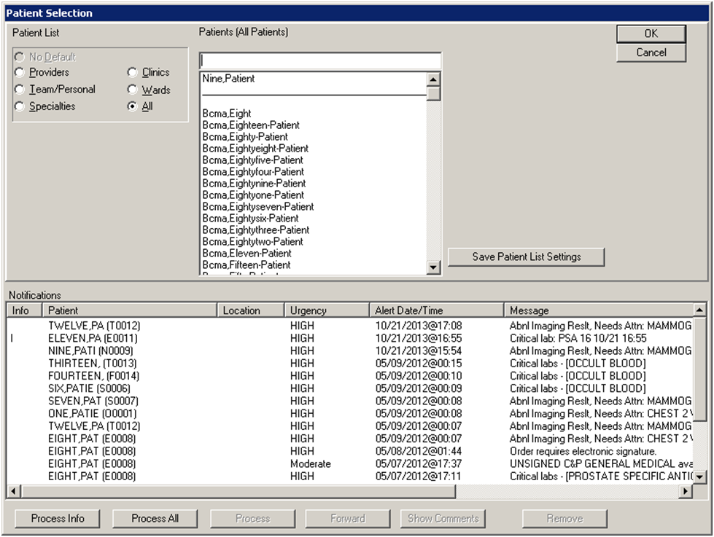

Figure 14 - CPRS Patient Selection Screen

### Navigation Hierarchy

#### CPRS/AWARE Screens

Navigation hierarchy starts with patient closeout at a desired selection of a new patient as below:

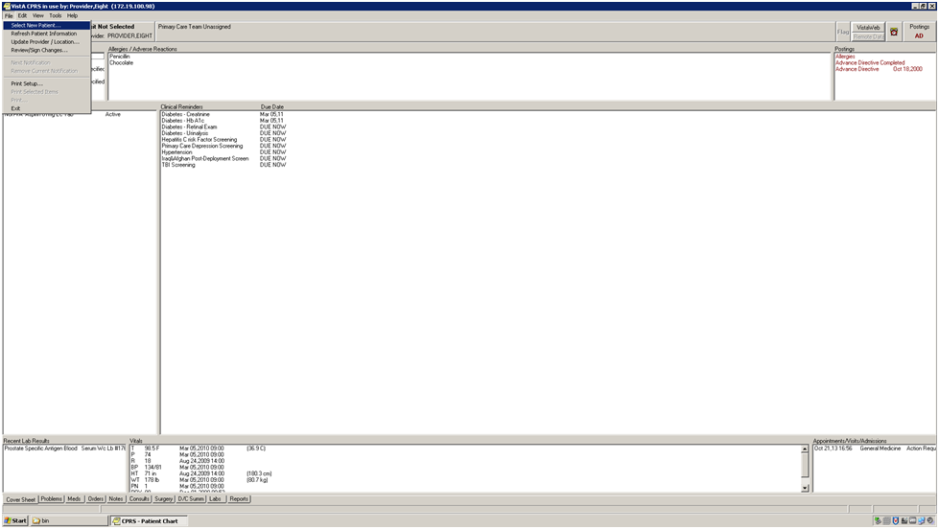

Figure 15 - Select New Patient

A normal CPRS patient selection screen as below is not presented if a provider’s previous patient’s alert (under FAT) has been detected as needing follow-up action:

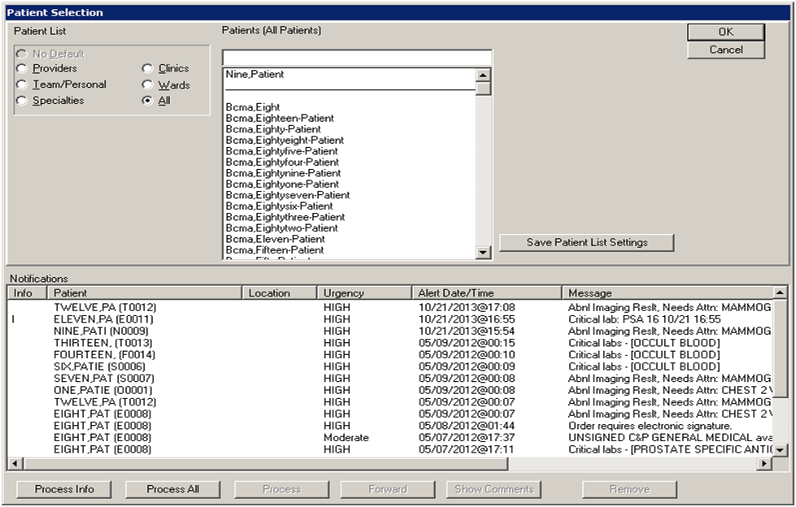

Figure 16 - Patient Selection

Instead, a FAT prompt screen is presented as below to the provider for an opportunity to do follow-up action. The elements of such form are described in section 6.2.5.3.17 Components of Forms.

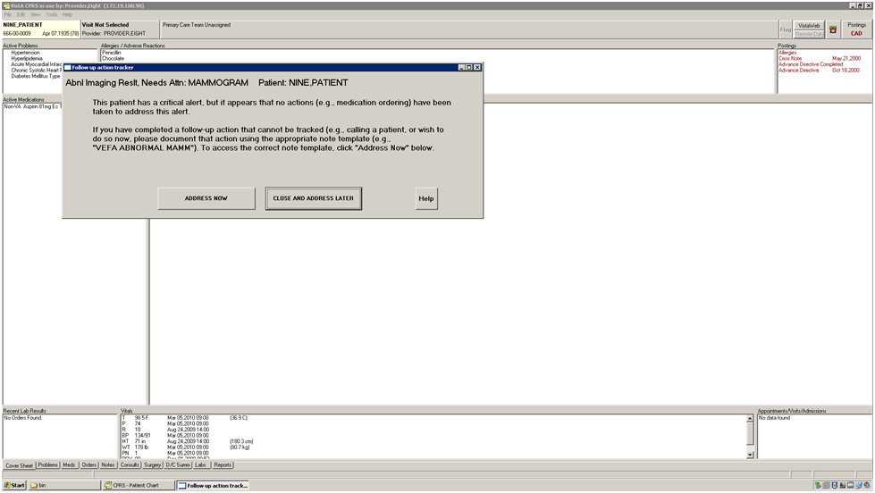

Figure 17 - FAT Prompt

Next, the provider can select the “ADDRESS NOW” button to bring up a Reminder Dialog that automatically re-directs the normal CPRS flow (as shown below), displaying a particular template in the Template drawer:

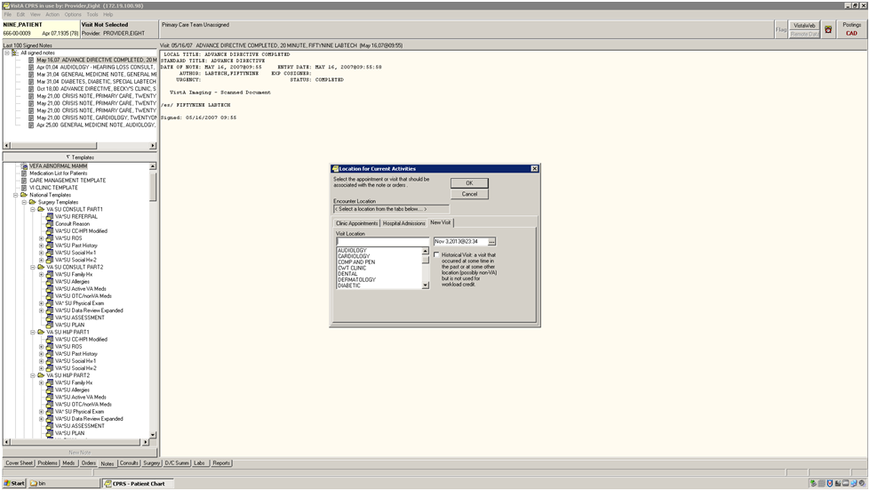

Figure 18 - Clinic Selection (above)

After selecting a new visit at a chosen visit location and progress note title, the provider will then automatically be redirected with a specific Reminder Dialog to do follow-up action(s) shown in the sequence below:

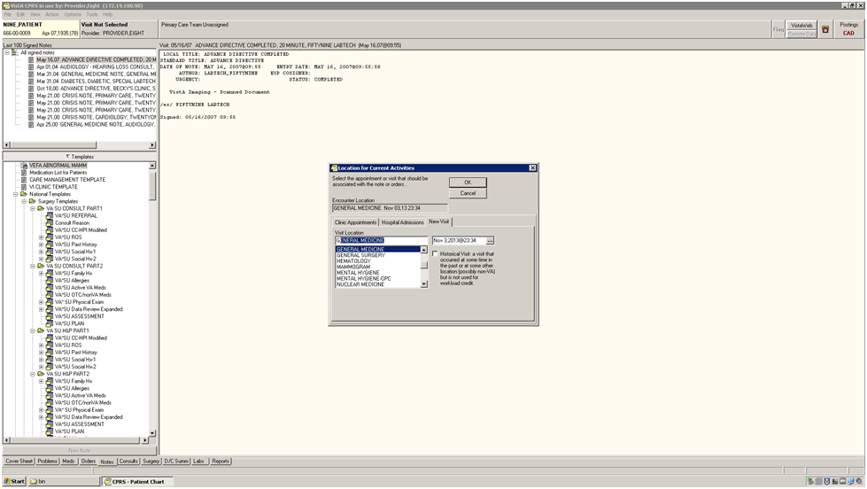

Figure 19 - Clinic Selection (continued)

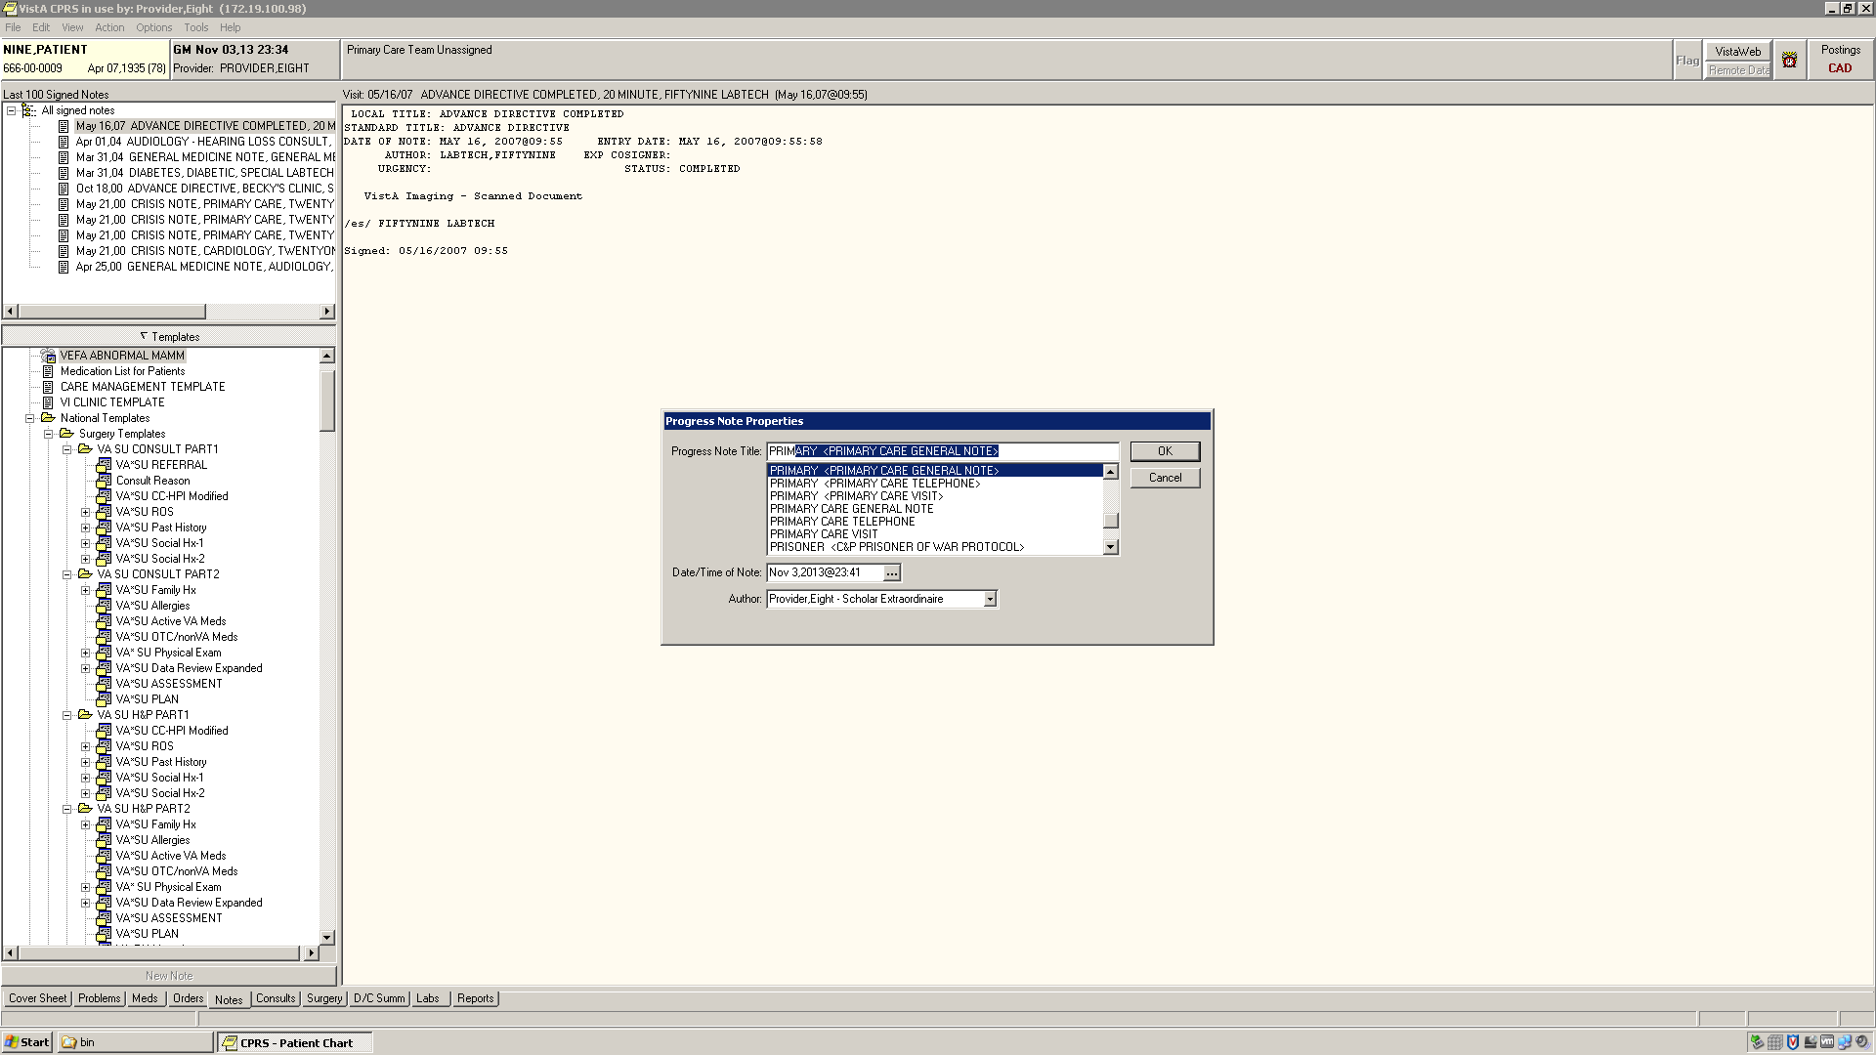

Figure 20 - Progress Note Title Selection

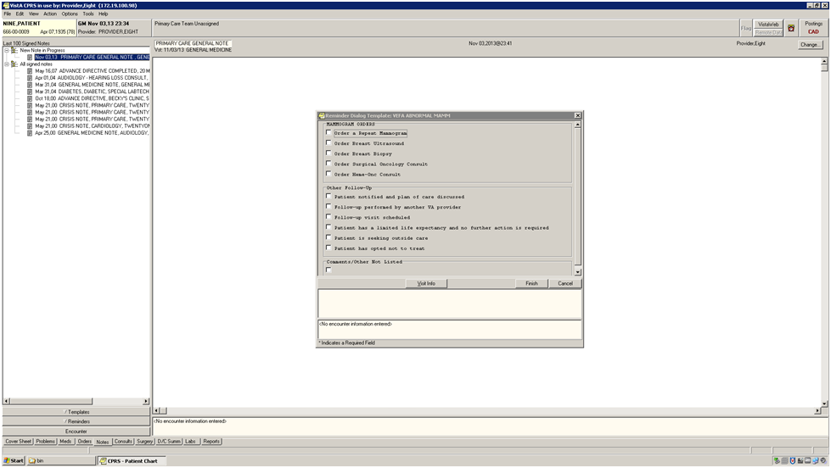

Figure 21 - Reminder Dialog Present

### Packaging and Installation

* KIDS file
* AWARE DLL
* Customized CPRS executable
* Installation Instructions Guide, and User Interface document

# Attachment A – Approval Signatures

The following members of the governing IPT are required to sign. Please annotate signature blocks accordingly.

__________________________________________________________  
Signed: Date:  
Blake Henderson   
Project Manager  
Innovation Coordinator

__________________________________________________________  
Signed: Date:  
Brian Stevenson   
Contracting Officer’s Representative  
Innovation Coordinator  
VHA OIA Innovation